Better Environment Award

Recognises tourism businesses that demonstrate an excellent understanding of the need to better protect our environment with specific emphasis on protecting sewers
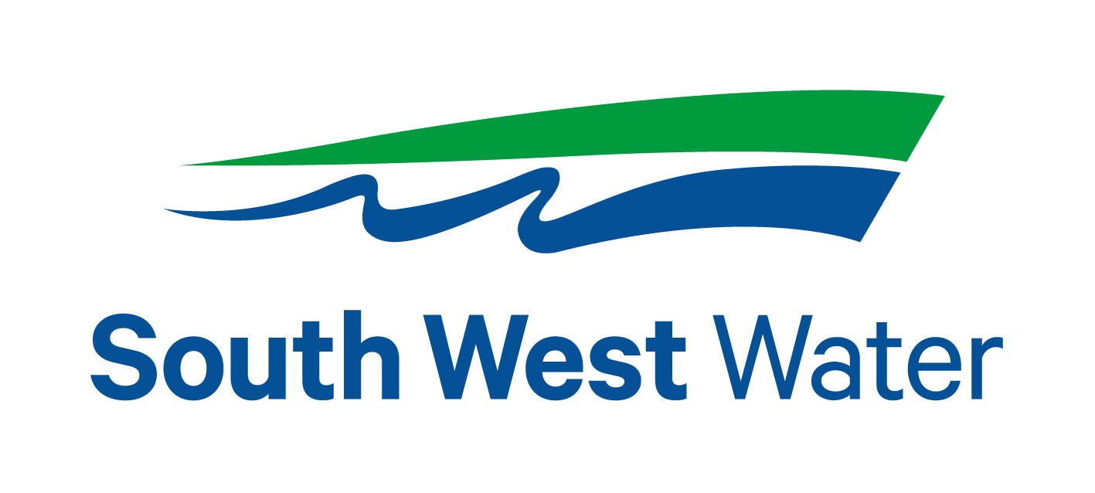
Headline Sponsor – South West Water

Blockages in the sewer network can increase the risk of flooding and damage to homes and properties. They can also harm the environment, which is why it’s important that we reduce the number of them to help keep our network flowing
South West Water are continuing to invest to maintain and improve the sewer network to help reduce the number of blockages, but we can’t do it alone and we need your help!

This entry form must be completed and submitted via email to awards@services4tourism.co.uk

Eligibility criteria

- Directly involved in tourism, making a contribution to the visitor economy with a significant proportion of business generated by people visiting from outside the local area.
- Businesses that serve food must have a minimum food hygiene rating of three out of five. The competition organisers reserve the right to refuse an application if this minimum requirement is not met at any point prior to the awards ceremony. An exception is made for new businesses who have not yet been graded.
- Businesses of all sizes can apply as this category is judged within the context and style of the business.
- Applications from a chain or group operator must relate to a single site and not multiple sites.
- The business must be open during the judging period
- For the purpose of eligibility for this competition, ‘trading’ means serving customers. If the business has not been trading this long, then they will need to wait to apply to the competition in 2024/25.

Applicant & business details
Applicant’s name & job title:

Applicant’s phone number:

Applicant’s email:

Business name & address:
Name of business application relates to. Give the name used to promote the business, as you wish it to appear in all publicity materials, on certificates, in presentations etc.:

Closures during judging period (1st June 2023 – 28th February 2024):

Promotional Description
Provide a promotional description of your business.
- Focus on its strengths and stand out features with regard to this category
- This wording will be used in PR and awards literature if you are shortlisted as a finalist
- 120 word maximum

Promotional Images
Please provide up to three landscape high resolution photos as attachments when emailing your completed entry form.
- Photos should relate to this category
- Photos should not be edited in any way e.g. embedded text or logos, a collage
- Only include photos that you own the copyright for
- If the photo requires a credit e.g. photographer, please provide details
- These photos will be used in PR and awards literature if you are shortlisted as a finalist

Online presence
Please provide links to your website

Please provide a link to your Environment information

Question 1
South West Water ask that only the 3p’s, pee , paper and poo go down the loo, with that in mind, what steps do you take to restrict which items go down your loos? For example wipes and sanitary items which contain plastic. (300 words max)

Question 2
Overusing toilet paper can cause sewer blockages. How do you encourage guests not to overuse toilet paper? (100 words max)

Question 3
Are you taking any other actions to prevent sewer misuse (for example do you have composting toilets?) and how do you promote this to your guests? How do you promote this with your staff and incorporate awareness within their training? (200 words max)

Question 4
1.6m tonnes of food waste is disposed of via household sinks and drains in the UK in one year. How do you encourage your guests to recycle & dispose of waste including food waste? (300 words max)

Question 5
As blocked sewers can cause flooding and pollute our beautiful beaches and countryside, tell us about how you are managing and improving environmental, social and economic impacts e.g. this may include, waste monitoring, community initiatives and responsible purchasing. Include details of sewer protection successes and whether you are able to attribute success directly to any of the improvements that you’ve made (300 words max)

Question 6
Each year SWW removes 4,000 tonnes of fat and food waste from the regions sewers, enough to fill 25 double decker buses. If you have food premises on site, what do you do with used cooking oils & fats? (200 words max)

Question 7
21% of blocked sewers are caused by waste fat, cooking oil and grease being poured down the sink. What grease management system do you consider to be the most effective in your kitchen? If you have self-contained kitchens and bbqs in guest accomodation, how do you encourage your guests to recycle/dispose of cooking oils, fats and food waste? (200 words max)

Question 8
Please outline any future plans you have for your business that might help protect our sewer network. (200 words max)

